**Task Description#1**

* **Zero-shot:** Prompt AI with only the instruction — Write a Python function to generate the Fibonacci sequence up to n terms

**Expected Output#1**

* A working function without using any sample inputs/outputs.

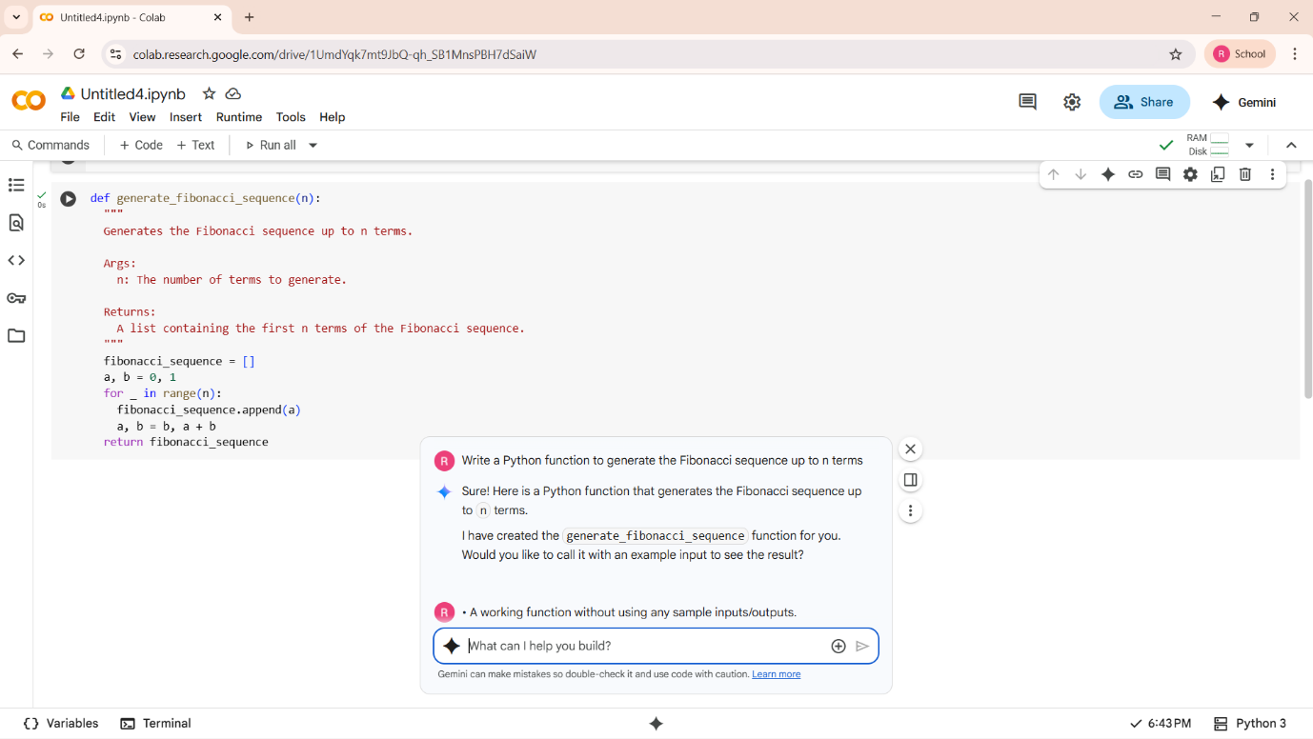SOL :- IT HAS GIVEN A WORKING FUNCTION

**Task Description#2**

* One-shot: Provide one example: Input: 100, Output: 37.78 to help AI generate a function that converts Fahrenheit to Celsius.

**Expected Output#2**

* A correct conversion function guided by the single example.

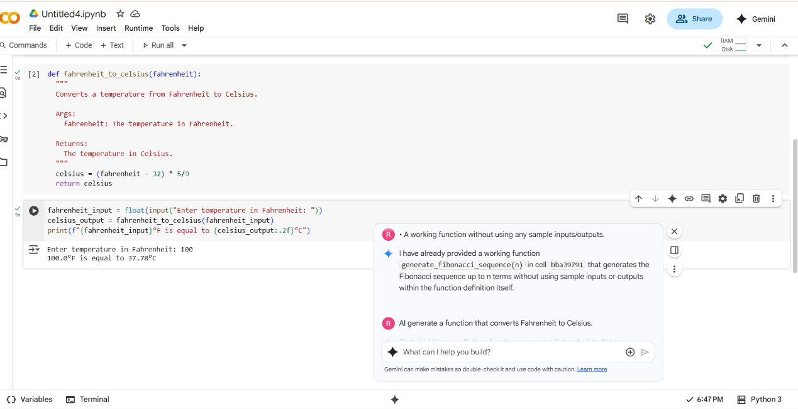

**Task Description#3**

* **Few-shot:** Give 2–3 examples to create a function that extracts the domain name from an email address.

**Expected Output#3**

* Accurate function that returns only the domain portion of an email (e.g., @gmail.com).

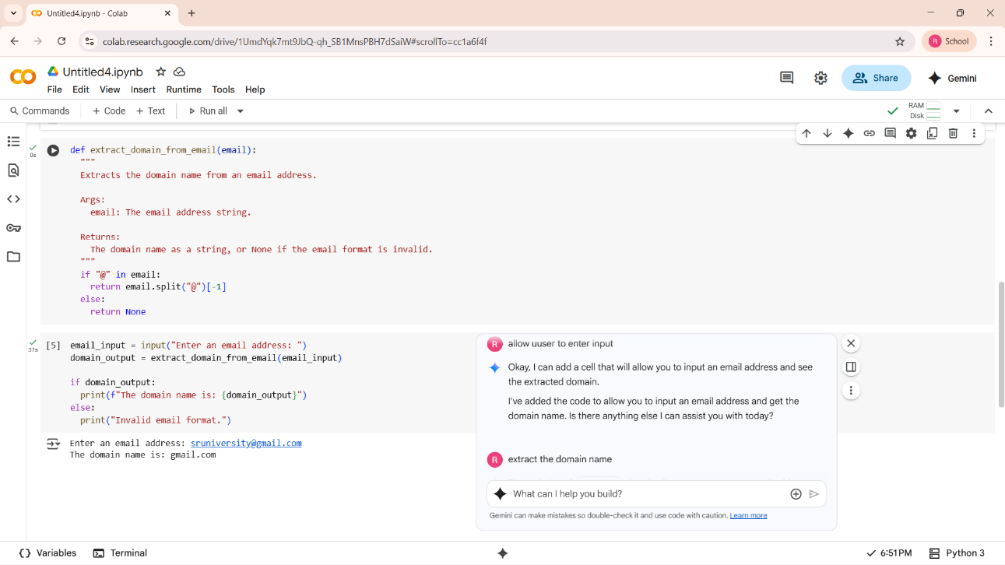

**Task Description#4**

* Compare zero-shot vs few-shot prompting for generating a function that checks whether a word is a palindrome, ignoring punctuation and case.

**Expected Output#4**

* Output comparison + student explanation on how examples helped the model.

**SOL:- ZERO SHOT PROMPTING**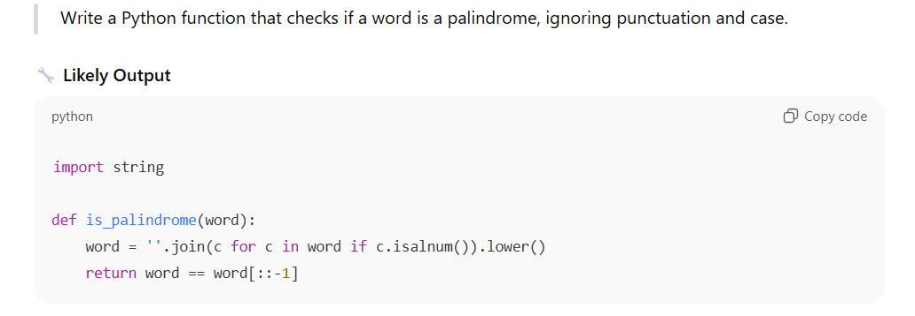

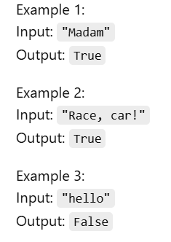

SOL 2:- FEW SHOT PROMPTING

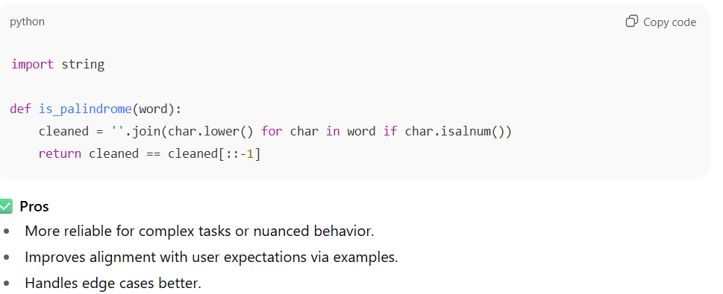

IN MY OPINION: AS PER TWO PROMPTING THE FEW SHOT PROMPTING IS MORE PRODUCTIVE.

**Task Description#5**

* Use few-shot prompting with 3 sample inputs to generate a function that determines the maximum of three numbers without using the built-in max() function.

**Expected Output#5**

A function that handles all cases with correct logic based on example patterns

SOL: FEW SHOT PROMPTING. WITH 3 EXAMPLES

